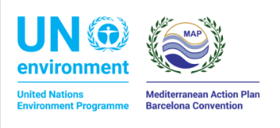

PRIORITY ACTIONS PROGRAMME REGIONAL ACTIVITY CENTRE – UNEP/MAP
SPLIT, KRAJ SV. IVANA 11

INVITATION TO TENDER

PROCUREMENT SUBJECT: Wetland restoration plan for Santa Maria Bay, Comino (Malta)

SIMPLE PROCUREMENT

Split, 3 March 2022

1. GENERAL INFORMATION
1.1. Client information:
Name: Priority Actions Programme Regional Activity Centre – PAP/RAC – UNEP/MAP (hereinafter: the Client)
Registered office - address: 21000 Split, Kraj Sv. Ivana 11
Telephone number: +385 (21) 340470
Website: www.paprac.org
- Contact person: Questions concerning the tender contents and format can be sent to the person in charge of communicating with Tenderers, Marko Prem, e-mail: marko.prem@paprac.org
- Procurement type: Simple procurement
- Estimated duration: Expected contract duration is 2,5 months.

2. INFORMATION ON THE PROCUREMENT SUBJECT MATTER
2.1. Background information
This project will contribute to the implementation of key relevant Decisions adopted by the Contracting Parties to the Barcelona Convention, namely the provisions under the ICZM Protocol i.e. Article 10 on Specific coastal ecosystems paragraph 1c requesting the Parties to undertake the restoration of degraded coastal wetlands, and the Post-2020 Strategic Action Programme for the Conservation of Biodiversity and Sustainable Management of Natural Resources in the Mediterranean Region (Post-2020 SAPBIO) adopted by COP 22 in December 2021.
The main goals of the Project are: To support restoration actions for wetland habitat in the Mediterranean in the framework of the ICZM Protocol and align with the UN Decade on Ecosystem Restoration.
The Project will be implemented based on the Small-Scale Funding Agreement (SSFA) between UNEP/MAP and PAP/RAC. The implementation of the activities within this Tender are fully funded by the UNEP, as agreed in the above mentioned SSFA from 14 February 2022.

2.2. Description of the procurement subject matter
The aim of this Tender is to prepare a Restoration plan for the creation of a coastal wetland area in Santa Marija Bay on Comino (Figure 1, Annex 1).
Further to the above, the Restoration Plan should include the following:
1. An analysis of the present situation and the Management Plan objectives for the site;
2. Prepare a Restoration plan with concrete actions for implementation in order to restore the coastal wetland habitats; and
3. Hold consultation meetings with stakeholders on the proposed Restoration plan.
The following considerations should be taken into account. Wetland restoration can have multiple benefits including biodiversity, human well-being, climate change adaptation and socio-economic conditions just to name a few. These benefits can be both collective and individual, impacting personal, ecological, cultural and socio-economic values. The type of restoration chosen for each site will be dependent on the actual state of the wetlands, the projected reference state and the actual and potential management options. It is it is important to avoid solutions that increase conflicts between different objectives (e.g., flood mitigation vs biodiversity) and to ensure that short term decisions are taken in a long-term perspective.
Restoration should take several principles for effective restoration into account, based on a participatory approach.
The first two principles actively search out the participation of stakeholders and the integration of many different types of knowledge including information and experience from scientists, practitioners and local and traditional systems. It is important to consider the governance processes in place, encouraging active stakeholder participation from the initial phases.
The next two principles define the reference ecosystem taking into account environmental change and ecosystem recovery processes. The reference ecosystem refers to the vision of the future for the wetland. How should the site look? What type of biodiversity should it support? What services should it provide? Deciding on the reference ecosystem is essential before undertaking any type of restoration activity. After identifying the reference ecosystem, the next principles attempt to set the goals and objectives of the restoration project, aiming to achieve the highest level of recovery possible over time. When undertaking the restoration project, it is essential to address the present and future threats in and around the restoration site.

2.3. Deliverables and deadlines
The deliverables and expected timeframes related to the activities/tasks defined in 2.2 are as follows:
Deliverables | Timeframe from date of signing
1.Submission of draft Restoration plan (Refer to Annex 5 for ToRs) | Week 6
2. Report of the consultation meeting with the stakeholders and local community | Week 10
3. Final Restoration plan | Week 10
After submission of the drat Restoration plan (Week 7) ERA and PAP/RAC will discussion it and provide feedback.
The deliverables shall be written in English in an electronic form (Word for Windows).

3. ELIGIBILITY OF ECONOMIC OPERATORS (SELECTION CRITERIA)
3.1. Technical and professional capacity
The Tenderer shall prove it has the following qualifications:
- Recognised degree in one of the following fields: environmental protection, nature protection, natural resource management, spatial planning
- Minimum of 5 years of experience in working on projects relevant to the Tender.
- Good knowledge of the English language, both in written and oral formats.

For the purposes of establishing the grounds set out in item 3.1. of the Invitation to Tender the Tenderer shall submit the following in his Tender:
- The Tenderer’s curriculum vitae (CV), clearly highlighting, among others, required technical and professional qualifications.
4. INFORMATION ON THE TENDER
4.1. Tender contents and format
The Tender proposal should contain the following elements:
- Tender sheet signed and filled in according to this Invitation to Tender (Annex 2);
- Curriculum vitae of the Tenderer, proving required technical and professional capacity;
- List of projects verifying expertise (see Ch. 5) of the Tenderer (Annex 3);
- Cost statement signed and filled in according to this Invitation to Tender (Annex 4).

4.2. Tender format and submission
Tender offers need to be drafted according to the requirements laid out in the Invitation to Tender.
Offers shall be sent electronically to the following e-mail addresses: procurement@paprac.org and marko.prem@paprac.org preferably with “Comino Restoration plan” as the e-mail subject.
4.3. Date, time and place of tender submission
Tender offers must be received by 14 March 2022, 12.00 hours.
All offers received after the bid opening deadline will be marked as late and excluded from the procedure.
  - The Tenderer may amend or withdraw his Tender before the Tender submission deadline. The amended Tender shall be submitted in the same manner as the original and clearly marked as amended. The Tenderer may withdraw his Tender by submitting a written statement before the Tender submission deadline. The written statement shall be submitted in the same manner as the original Tender and clearly marked as a statement of Tender withdrawal. Alternative Tenders are not permitted.
4.5. Tender currency: US Dollars (USD).
The Contractor shall express the price in USD, and the payment will be made in USD. However, payment can be made in other currency using the exchange rate of the Client’s bank (OTP bank), valid on the date of the payment.
No price variation due to escalation, inflation, fluctuation in exchange rates, or any other market factors shall be accepted by PAP/RAC after it has received the Proposal.
  - Language and script: The Tender shall be drafted in English language, using the Latin script.
  - Period of validity: 15 days from the tender submission deadline.
  - Price setting method
The Tender price shall be expressed in USD and written in numbers. The tender price cannot be altered.
The tender price consists of pre-VAT price, VAT and total price.
- Pre-VAT price includes all costs related to the performance of the services. For natural persons it includes all relevant taxes and contributions in accordance with the Croatian legislation.
- VAT needs to be indicated.
- Tenderers registered in Croatia express VAT: 0% if they are not in VAT system and 25% if they are in VAT system.
- Tenderers outside Croatia (natural persons and companies, in or out of VAT system) do not express VAT, but indicate “reverse charge” (see also Annex 4).
- Total price is the sum of pre-VAT price and VAT.

When evaluating the tenders, the Client will take into account the total price.
Transport fees and accommodation expenses related to the Proposal (if any) are not included and will be covered by the Tenderer as an additional expense.

5. AWARD CRITERIA
The Tender will be awarded according to the most economically advantageous tender (MEAT) criteria.
The following table sets out the criteria, units of measure, labels and their relative importance. They will be applied to Tenderers who satisfy technical and professional capacity criteria set in Ch 3.1. The MEAT award criteria are the following:
- proposed price (Annex 4);
- expertise of the Tenderer (Annex 3); and
Determining the MEAT according to the above criteria for selecting the MEAT will be done as follows: after the Client has determined the score value by individual criteria for each Tenderer, the points awarded to Tenderer according to each of the criteria will be summed in order to obtain the total number of points for each Tenderer. The most favourable Tenderer will be the one who has earned the highest total score according to all the above criteria.
At that, the MEAT is equal to the highest total score resulting from the ranking of the Tenders; the total maximum number of points is 100.00 with the total points being calculated in two decimal places. In case that two or more Tenders achieve equal number of points, the one received earlier will be chosen. As a proof, data will be used on the order in which tenders have been received.

Criteria | Criteria label | Description and measuring unit | Methodology | Number of points | Maximum
Price | P | The Tender price, i.e. the financial Tender amount in USD including VAT, if applicable | C = (Lowest Tender price/price of the tender) x 50.00 | 50 | 50
Expertise | E | Number of projects related to wetland management and restoration including its planning in which the tenderer was involved as the expert | 1 | 10 | 50
 |  |  | 2 | 20
 |  |  | 3 | 30
 |  |  | 4 | 40
 |  |  | More then 4 | 50

Selection of the most economically advantageous Tenders (ENP) will determine the basis for evaluating the criteria for each individual Tender according to the delivery of the requested Tenderer's documentation, in the appropriate form: ENP = P + E.
For the purposes of establishing the grounds set out in item 5. of the Invitation to Tender the Tenderer shall submit the following in his Tender:
- List of projects verifying expertise of the Tenderer (Annex 3);

6. DUE DATE, CONTRACTING AND TERMS OF PAYMENT
The Contract will be made in US dollars.
If selected contractor is resident of the Republic of Croatia, payments will be in kuna currency (HRK), using the exchange rate of conversion of the OTP Bank d.o.o. valid on the date of payment.
The Client shall make payment/s to the Tenderer upon the submission of the deliverable/s and its validation by PAP/RAC.
The First instalment (50 %) after submission of the deliverable 1 (specified in Ch. 2.3)
The Final instalment (50 %) after submission of the deliverables 2 and 3 (specified in Ch. 2.3)
All legal person (in or our VAT system) and natural person which are in VAT system are required to issue invoice/s.
An advance payment by the Client is not permitted.

Annex 1

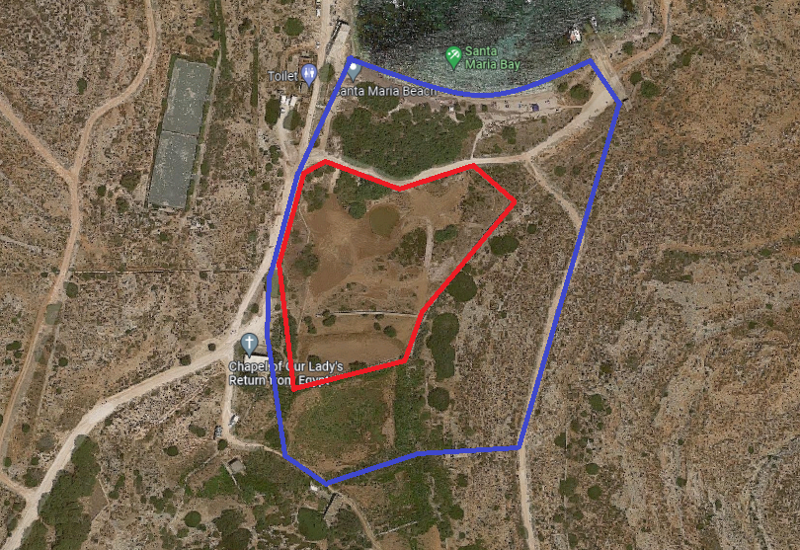

Figure 1 – Area of Study Marked in blue (AoS) and Area of Interest (AoI) marked in red.

Annex 2

Tender sheet

Tender date:
Contracting Authority: Priority Actions Programme Regional Activity Centre (PAP/RAC) – UNEP/MAP, Kraj Sv. Ivana 11, 21000 Split, Croatia
Subject of procurement: Restoration plan for a wetland (Comino island, Malta)

Tenderer information:
Tenderer’s name and registered seat
PIN
Bank name
IBAN
SWIFT
Name, family name and position of a person / persons authorised to sign the public procurement contract
Name and title of the contact person:
Mail address:
E-mail address:
Telephone number:
Tender price:
Total pre-VAT price in USD
VAT amount (25%)
Total price with VAT in USD
Period of bid validity: (at least 15 days after the tender submission deadline)

For Tenderer:

(Signature of a legal representative)

Annex 3

Practical experience verifying expertise of the Tenderer

Relevant experience of the tenderer- expert (Name and Surname) ________________________, Number of projects related to wetland restoration including its planning in which the tenderer was involved as the expert:

No. | Experience (name of the project) | Role of the expert | Year (start-end)
1.
2.
3.
4.
5.
6.

Annex 4

Cost statement

Technical description and cost statement: Restoration plan for a wetland (Comino island, Malta)

No. | Deliverable description | Unit | Number of units | Unit price in USD (without VAT | Total item price (without VAT)
1. | Draft Restoration plan | Expert Days
2. | Report of the consultation meeting with the stakeholders and local community | Expert Days
3. | Restoration plan | Expert Days
 | Total pre-VAT price in USD
 | VAT amount (25%)
 | Total price with VAT in USD

In______, __.__ 2022
________________________________
(Full name of the legal representative)

________________________________
(Signature of the legal representative)

Annex 5

Terms of Reference

Ecological restoration plan aimed at:

- Developing a plan with technical specifications for the enlargement and restoration of the AoI into a wetland habitat;

- Incorporating the relevant Management Objective, MO4. To ensure the enhancement of the structure and function of habitat 1420, in the Kemmuna u l-Gżejjer ta’ Madwarha Management Plan;

- Eradicating invasive species that have become established in the AoS in line with “Guidelines on managing non-native plant invaders and restoring native plant communities in terrestrial settings in the Maltese Islands”;

- Planting of indigenous species typical of wetland habitats with a view towards extending the physical coverage of the habitats in question;

- Achieving an extension in the area of coverage of the wetland through a scientific habitat restoration / engineering intervention; and

- Develop the AoI into a wetland, to function as an important refuge of avifauna possibly encouraging nesting, resting and breeding in the area.

Or national identification number according to the economic operator’s country of establishment, if applicable
Economic operators in Croatia that are not in VAT system put 0. Economic operators outside the Republic of Croatia (natural persons and companies) in or out of VAT system, in the place of VAT put note “reverse charge”
Add rows, as necessary

