Annex 5

STAKEHOLDERS ANALYSIS

Introduction

Stakeholder can be defined as any individual, group, or institution who has interests in natural resources of the project area, and who affects or can be affected by project’s actions.

Stakeholder Analysis (SA) is an important and flexible tool which includes identification of all relevant stakeholders and assessment of their interests and the ways in which these interests affect project riskiness and viability. The ultimate outcome of proper SA is selection of stakeholders with whom the user can jointly work towards goals that will reduce or reverse the threats to certain environment. SA is also a very useful tool for communicating the benefits of proposed project and creating a strong engagement of public. See “Glossary” in the Annex.

Stakeholder analysis is a relatively simple process, and can be undertaken in a variety of ways. In this particular guideline, SA is based on four steps, involving three tables that need to be completed:
Step 1. Identification of key stakeholders
Step 2: Analysis of institutional stakeholders
Step 3. Assessment of stakeholders' importance and influence
Step 4. Assessment of stakeholders' “place in process”.

Step 1. Identification of key stakeholders

The essential step of the SA is the identification of key stakeholders that have a concrete "stake" in a specific issue or topic. The list of stakeholders should be comprehensive and exhaustive, and should include people and groups from public sector (e.g. various ministries and government agencies, authorities at local, regional and national level, universities); private sector (e.g. banks, various energy, water, construction and all other private companies); civil society (e.g. international projects, programmes and foundations; civil networks and NGOs); and various other community members (e.g. farmers, local community representatives, religious leaders, ethnic minorities, indigenous groups).

Table 1. Identification of key stakeholders

STAKEHOLDER
Name, contact | Short presentation  (main role, interests, etc.) | Private sector | Public sector | Civil society | Community members

Step 2: Analysis of institutional stakeholders

A particular attention in stakeholders analysis should be paid to institutions involved in the process. Institutional setting can be a rather complex issue to deal with, especially due to the fact that it involves so many different actors. Institutional capacity to apply and management instrument and to actually make it operational, can be a major limiting factor. Therefore, the analysis of the status and role of all the relevant institutional actors (various ministries, departments, agencies, divisions, units etc) involved in the specific ICZM process is one of the crucial steps.
Institutional analysis (Table 2) should include all the relevant institutions which are somehow involved in the ICZM process, along with the analysis of their remit, role, relevance, responsibility, capacity, and resources (incl. financial) and skills with ICZM process:

- Remit/Role/Relevance/Responsibility
Represents the degree to which institutions are actually involved with and committed to the successful application of coastal management. It should also include the actions they are allowed and expected to make in terms of the responsibilities and their executive powers available in performing coastal management tasks, actions and decisions.
It includes:

  - Functional and spatial remit within the project area
  - Degree of awareness of coastal problems
  - Degree of actual involvement and possible influence on the coastal management process
  - Potential and willingness for cooperation
  - Limitations in the extent to which institutions allow integration of interests, responsibilities and executive powers

- Capacity
What are the institutions' specific skills related to the various management tasks (analysis, evaluation, design and implementation etc.), human resources and facilities?
It includes:
  - Decision making capacity: Is the institution a decision-maker, on what legal basis? Selection of most appropriate options for successful coastal planning, as well as its interpretation and evaluation.
  - Institutional design capacity: capacity for designing measures which are legally, administratively and operationally feasible.
  - Monitoring capacity: potential for monitoring and inspecting the coastal areas, identification of coastal-related issues and the efficiency of implementing technical and institutional measures.
  - Facilities for analysis: analytical tools for coastal analysis (equipment, for example).

- Resources/Skills
- Resources including technical, personnel, data and information provider, facilitator, etc.
- Extent of the financial resources available for institutions to use for various management tasks, as well as the institutions' possibilities to finance or raise money for financing coastal management related tasks and activities.

Table 2. Institutional analysis
Institution
Name | Remit | Role/ Responsibility | Capacity | Decision-making | Resources/Skills

Step 3. Assessment of stakeholders' importance and influence

Based on the identification and classifications of stakeholders in two previous steps, the third step in the SA considers valuation of stakeholders' importance and influence. This step includes (for each stakeholder) assessment of stakeholder’s political, social and economic status, degree of organization, control over important resources, informal influence (personal connections), interrelations with other stakeholders and stakeholder’s importance for the success of the project.

Both the influence and importance of different stakeholder groups can be ranked along simple scales, and mapped against each other, such as in the Table 3.

Table 3. Stakeholder categories, their characteristics and level of indicated engagement

Stakeholder category | Characteristics
Stakeholder category | Power | Interest | Legitimacy
A.1 | High/medium | High/medium | High/medium
A.2 | High/medium | High/medium | Low/none
B.1 | High/medium | Low/none | High/medium
B.2 | High/medium | Low/none | Low/none
B.3 | Low/none | Low/none | High/medium
C.1 | Low/none | High/medium | High/medium
C.2 | Low/none | High/medium | Low/none

- Power to affect the management instrument (i.e. ICZM plan, coastal plan, resource management plan, protection management plan, strategy or programme) implementation and outcomes through control of economic wealth, political authority, fear through intimidation, access to communication channels etc., i.e. the power bestowed to them by the sum of their resources;
- Interests in the management instrument implementation and outcomes, whether they are high, low or neutral where net gains or losses are concerned;
- Legitimacy of the stakeholders provided by law or local custom and refer to the rights, responsibilities of the stakeholder, the level of resolve, or determination in exercising these rights and responsibilities in relation to the management instrument implementation and outcomes.

Category A.1: High/medium power, High/medium interest, High/medium legitimacy
Stakeholders belonging in this category are characterised by a combination of high or medium power to promote or oppose the implementation of the management instrument, high or medium interest in its outcomes and the legitimacy attributed by their legal rights or responsibilities to be engaged in the public participation procedures. These characteristics make them very valuable for any management instrument activity implementation, since they can influence, promote or inhibit it. It is advisable to engage these stakeholders at the level of involvement and collaboration.

Category A.2: High/medium power, High/medium interest, Low/none legitimacy
Stakeholders belonging in this category are characterised by a combination of high or medium power as well as high or medium interest to influence the implementation of the management instrument and its outcomes, despite lacking the legitimacy in the means of legal rights, responsibilities or resolve to be engaged in the public participation procedures. Their characteristics imply that they have influence which they can use if they believe their interests are affected either positively or negatively by the management instrument. It is therefore advisable to engage these stakeholders, thoroughly inform them of the management instrument, consult with them on its implementation and involve them where appropriate.

Category B.1: High/medium power, Low/none interest, High/medium legitimacy
Stakeholders belonging in this category are characterised by a combination of high or medium power as well as high or medium legitimacy to be involved in the management instrument implementation derived by their legal rights or responsibilities, despite the fact that they have little of nothing to gain or lose from the management instrument outcomes. Their characteristics bestow them influence which could be employed creatively and objectively. These stakeholders, may be consulted and involved on issues of management instrument implementation and also collaborate where appropriate for the benefit of the management instrument.

Category B.2: High/medium power, Low/none interest, Low/none legitimacy
Stakeholders belonging in this category are characterised by high or medium power, but low or no interests or legitimacy in the management instrument implementation, as this would be derived by their legal rights or responsibilities. This combination means these stakeholders are not taking an active approach towards the implementation of the management instrument, however they should be thoroughly informed and consulted, since their characteristics may change, in which case they will move to categories A.1, A.2, or B.1.

Category B.3: Low/none power, Low/none interest, High/medium legitimacy
Stakeholders belonging in this category are characterised by high or medium legitimacy to participate in the implementation of the management instrument as this is derived by their legal rights or responsibilities, while having little of nothing to gain or lose and little or no power to influence the management instrument outcomes. Their characteristics imply their concern on the management instrument, as well as their position of responsibility in the implementation of activities and use of outputs of the management instrument. These stakeholders should be involved on issues of management instrument implementation and their collaboration should be sought out where appropriate for the benefit of the management instrument.

Category C.1: Low/none power, High/medium interest, High/medium legitimacy
Stakeholders in this category are found in a rather vulnerable position since, according to their characteristics, they do not have the power to defend their interests of assert their legitimacy, however high these may be. Because of this, it is imperative that any such stakeholders be given the opportunity to input and participate in the management instrument implementation and therefor their collaboration should be actively sought.

Category C.2: Low/none power, High/medium interest, Low/none legitimacy
Stakeholders belonging in this category are characterised by low or no power and legitimacy to participate and affect the implementation of the management instrument, in spite of having high or medium interests to do so. The high or medium interest, therefore indicates that the collaboration of these stakeholders in the implementation of the management instrument should be actively sought out.

Step 4. Assessment of stakeholders' “place in process”

Finally, all stakeholders could be tallied with the proposed activities for public participation, following an ascending degree of engagement. This is illustrated in the figure below, adapted from the International Association for Public Participation's Spectrum for Public Participation.

Figure 1. The ladder of participation
INCREASING LEVEL OF PUBLIC IMPACT

INFORM | CONSULT | INVOLVE | COLLABORATE
Provide the stakeholders  with balanced and  objective information  to assist them in  understanding the  problems, alternatives  and/or solutions. | Obtain stakeholders  feedback on analysis,  alternatives and/or  decisions. Keep the stakeholders  informed, listen to  and acknowledge their  concerns and  provide feedback  on how public  input influenced the  decision. | Work directly with  stakeholders throughout  the process to ensure  that public concerns  and aspirations  are consistently  understood and  considered. Ensure that  stakeholders' concerns and  aspirations are directly  reflected in the  alternatives developed  and provide feedback  on how their  input influenced  the decision. | Partner with  stakeholders in each  aspect of the  decision, including  the development of  alternatives and the  identification of the  preferred solution.  Look to the stakeholders  for direct advice  and innovation in  formulating solutions  and incorporate  your advice and  recommendations  into the decisions to  the maximum extent  possible.

In the third step, the type of participation of different stakeholders should be plotted against their stage in ICZM process (Table 4). In this way, users can have a clear insight in which type of action at what “step” of ICZM process should stakeholders be involved. See “ICZM Process” in Annex.

Table 4. Assessment of stakeholders' “place in process”

 |  | Level of engagement/ participation
 |  | Inform | Consult | Involve | Collaborate
Stage in ICZM process | Establishment
Stage in ICZM process | Analysis and Futures
Stage in ICZM process | Setting the Vision
Stage in ICZM process | Designing the Future
Stage in ICZM process | Realising the Vision

Any details relevant to the stakeholder analysis which do not fit into the context of these three tables should be provided in the Annex of the SA document, in order to improve the quality of the analysis.

Background reading:

Department of Sustainability and Environment (2008) Stakeholder Analysis (Stakeholder Matrix), DSE – The State of Victoria, Australia, Available at http://www.dse.vic.gov.au/DSE/wcmn203.nsf/LinkView/86D3534A103DB113CA257089000A2FB3B3D050C7331FFEBBCA257091000FEF77

Ecoregional Conservation Strategies Unit (2000) Stakeholder Collaboration; Building Bridges for Conservation, WWF, Washington, DC: ECSU, Research and Development, 86 pp, Available at http://www.protectedareas.info/upload/document/stakeholdercollaboration.pdf

EC-FAO Food Security Information for Action Programme(2007) Stakeholder Analysis, Collaboration and Advocacy Techniques e-learning course, Available at http://www.foodsec.org/DL/course/shortcourseFK/en/pdf/trainerresources/PG_StakeHolder.pdf

Overseas Development Administration (ODA) (1995) Guidance Note on How to do Stakeholder Analysis of Aid Projects and Programmes. London: Social Development Department, Overseas Development Administration, Available at http://www.euforic.org/gb/stake1.htm

Schmeer, K. (2000). Stakeholder Analysis Guidelines. Policy Toolkit for Strengthening Health Sector
Reform. Washington, D.C. , Regional Office of the World Health Organization, 33 pp, Available at http://www.eestum.eu/voorbeelden/Stakeholders_analysis_guidelines.pdf

The World Bank Group (2001) Stakeholder Analysis, On-line source - available at http://www1.worldbank.org/publicsector/anticorrupt/PoliticalEconomy/stakeholderanalysis.htm

WWF (2005) Cross-Cutting Tool: Stakeholder Analysis. In the series: Resources for Implementing the WWF Standards, 8 pp., Available at http://assets.panda.org/downloads/1_1_stakeholder_analysis_11_01_05.pdf

http://www.biodiversity.ru/coastlearn/planning-eng/is_analysis.html

Annex

GLOSSARY

Stakeholder: any individual, group, or institution who has a vested interest in the natural resources of the project area and/or who potentially will be affected by project activities and have something to gain or lose if conditions change or stay the same.
Primary stakeholders: those that ultimately affect or are affected, either positively or negatively
Secondary stakeholders: are the intermediaries in the project/policy/initiative delivery process.
Key stakeholders: (primary or secondary) are stakeholders that have significant influence upon or importance for the project.
Internal stakeholders: are already committed to the project.
External stakeholders: are people who are impacted by the project.

Power
The quantity of resources (human and financial resources, political influence, ability to enforce will, access to information and communication) available to each of the stakeholders and the ability to mobilize them in favor or against the project/policy/initiative.

Interest
Interest can be manifold. It could be that the stakeholder is personally affected in regard to her/his social and economic personal well-being, (e.g. physical health, leisure, costs for services such as sewage treatment, provision of drinking water, cultural values etc.); it could also regard the business of the stakeholder (e.g. agriculture, fisheries, industries, navigation etc.); it could be the stakeholder is advocating superior interests of the society such as environmental protection or social justice.

Legitimacy
Legitimacy can be provided by law or local custom and refer to the rights and responsibilities of the stakeholder, the level of resolve, or determination in exercising these rights and responsibilities.

Community engagement
The process of working collaboratively with and through groups of people affiliated by geographic proximity, special interest, or similar situations to address issues affecting the well-being of those people. In the context of civil renewal, community engagement is the term for processes which help to build active and empowered communities. Its characteristics include enabling people to understand and exercise their powers and responsibilities as citizens, empowering them to organise through groups to work for their common good, and requiring public bodies to involve citizens in influencing and carrying out public services

Management instrument: ICZM plan, strategy or programme, coastal plan, resource management plan, protection management plan, as well as other similar instruments contributing to coastal zone management.

ICZM Process FE

This ICZM Process is intended to guide, i.e. it is the “how“ of ICZM, but it should be adapted, however, to individual local circumstances which will dictate changes to this Process within the overall framework. The ICZM Process is structured into 5 key stages represented in the diagram on the next page. The 5 stages are further structured into Key Tasks for each stage. They should be used as a checklist to help set up various management instruments for coastal zone management such as an ICZM plan, coastal plan, resource management plan, protection management plan, strategy or programme.
ED BACK FEED BACK
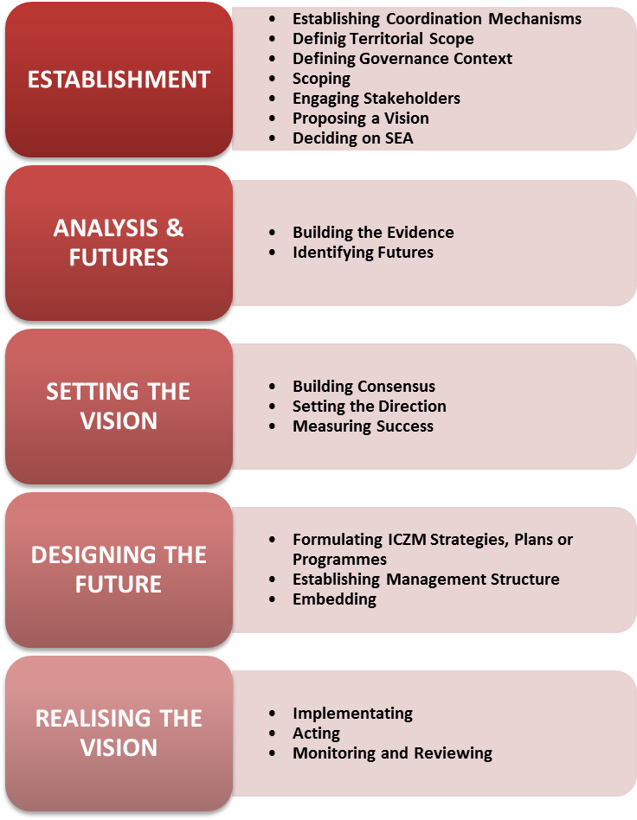

INTEGRATION
FEED BACK

More details available at: http://www.pegasoproject.eu/wiki/ICZM Process

